**Unit Testing of LOG-INT-03 SHAW OM PointOfSales From Cloud to DBCS**

**And LOG-INT-03 SHAW OM PointOfSales From DBCS to LGF**

1. **Testing of** **LOG-INT-03 SHAW OM PointOfSales From Cloud to DBCS**

**Update current_run_date and last_successful_run**

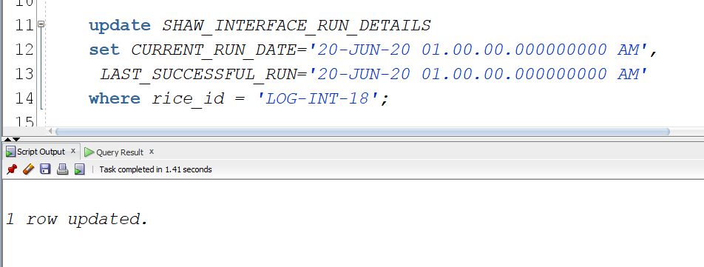

Check data for the dates in report

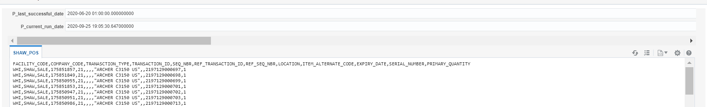

Submit Integration

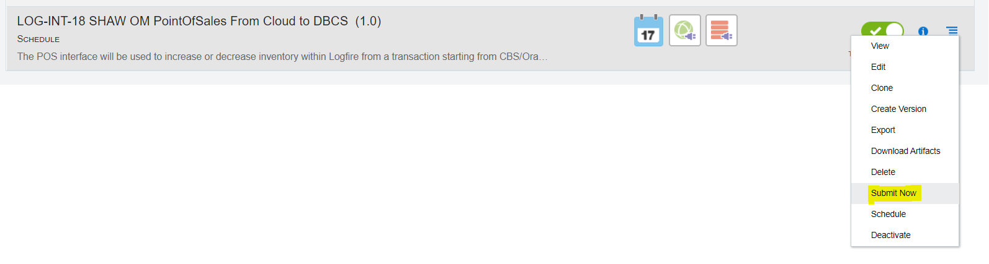



Data Inseted into POS Staging table

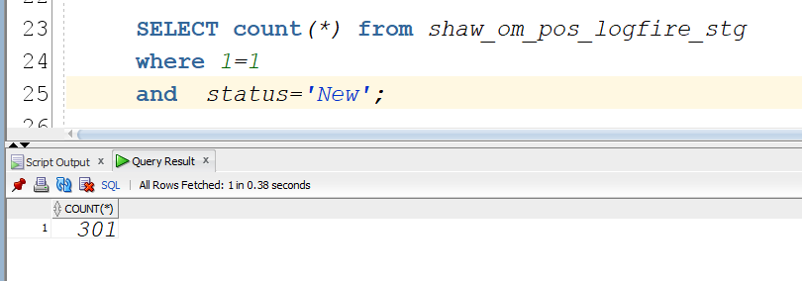

1. **Testing of LOG-INT-03 SHAW OM PointOfSales From DBCS to LGF**

**Place project and expense issue related files in LOGFIRE_OUTBOUND/Out path in ftp**

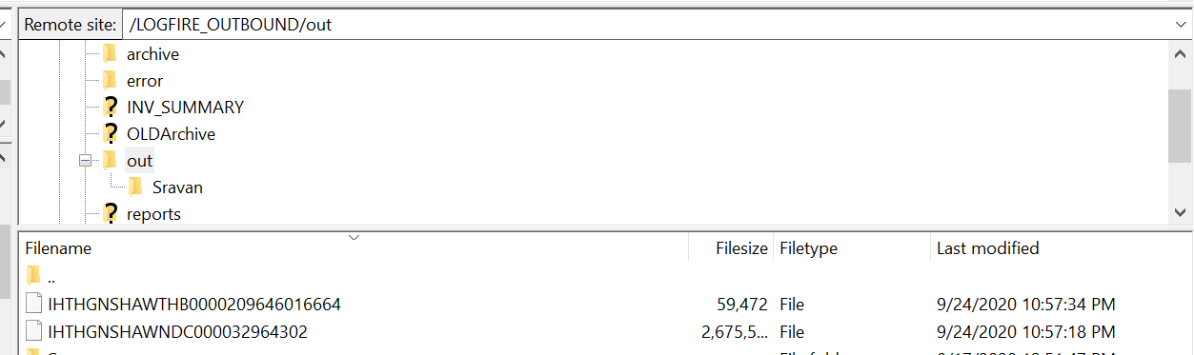

Submit SHAW INV Transactions Interface From LGF To DBCS

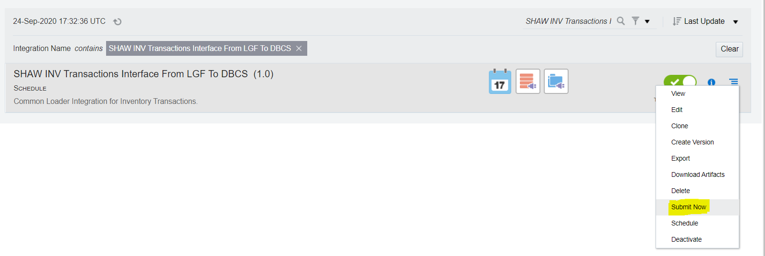



Files has been picked up by integration

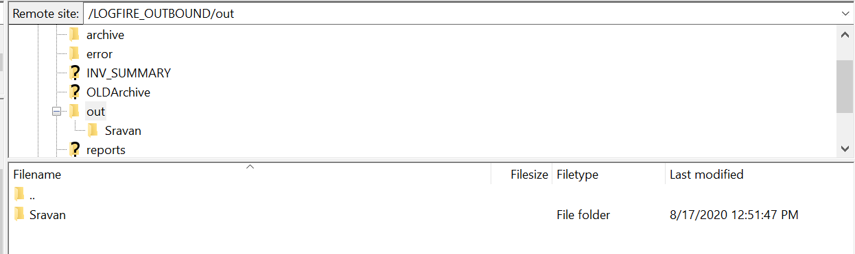

Data inserted into “shaw_inv_trx_logfire_stg” table

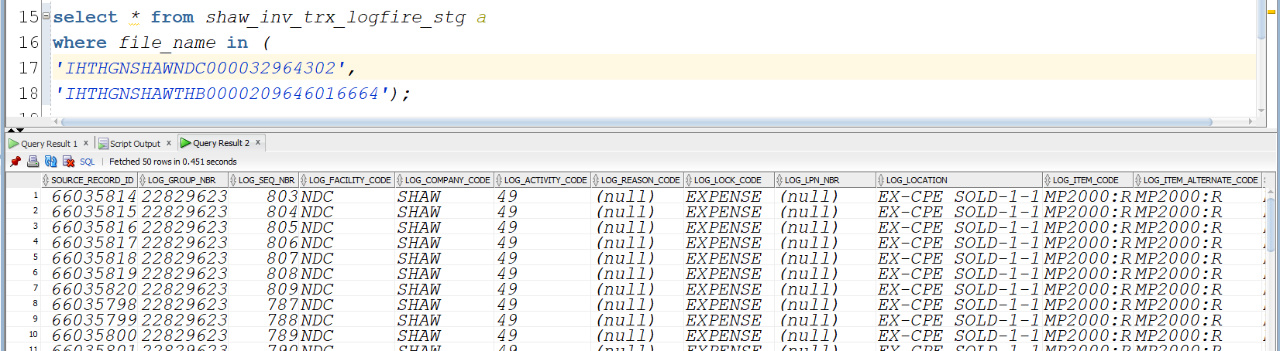

Submit “LOG-INT-23 Shaw Inv Project Expense Issue WMSToERP” Integration

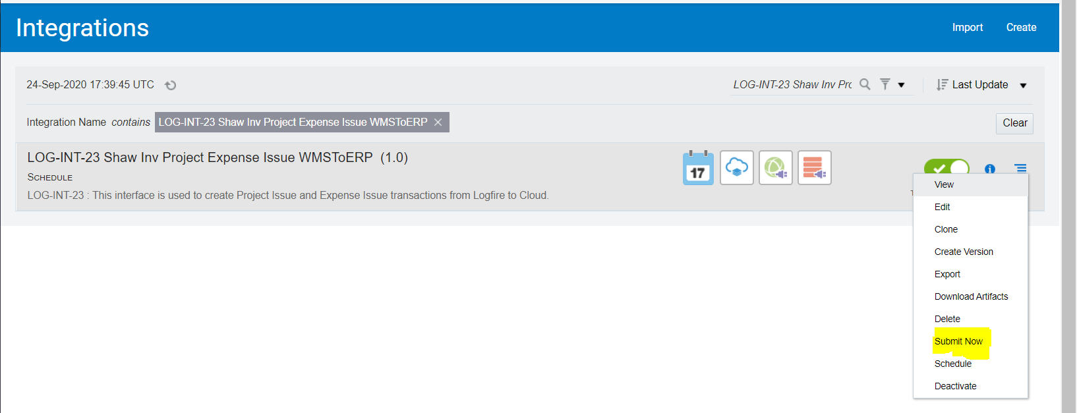

Check data of new records for pos_status 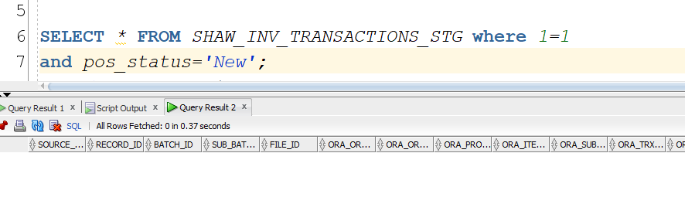

After submitting integration

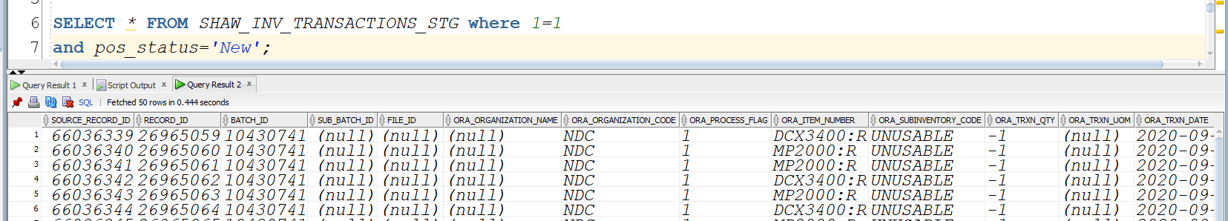

Now pos_status is updating for expense issue

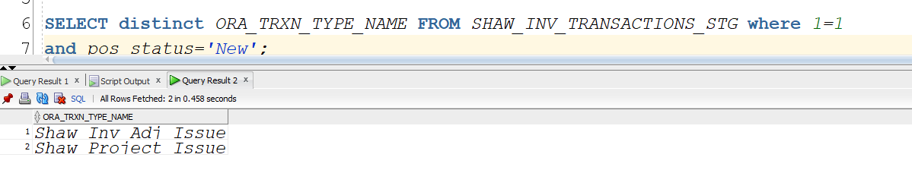

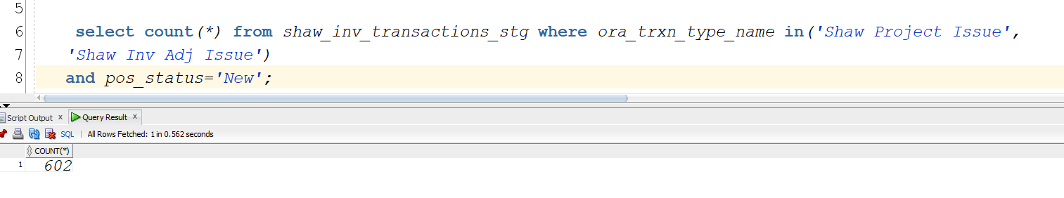

Check data of processed records for pos_status

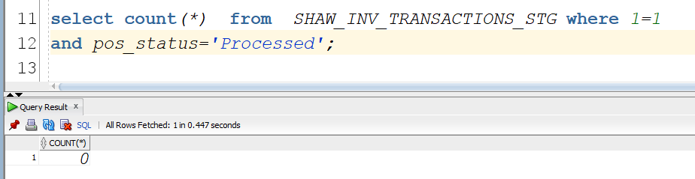

Submit integration “LOG-INT-18 SHAW OM PointOfSales From DBCS to LGF”

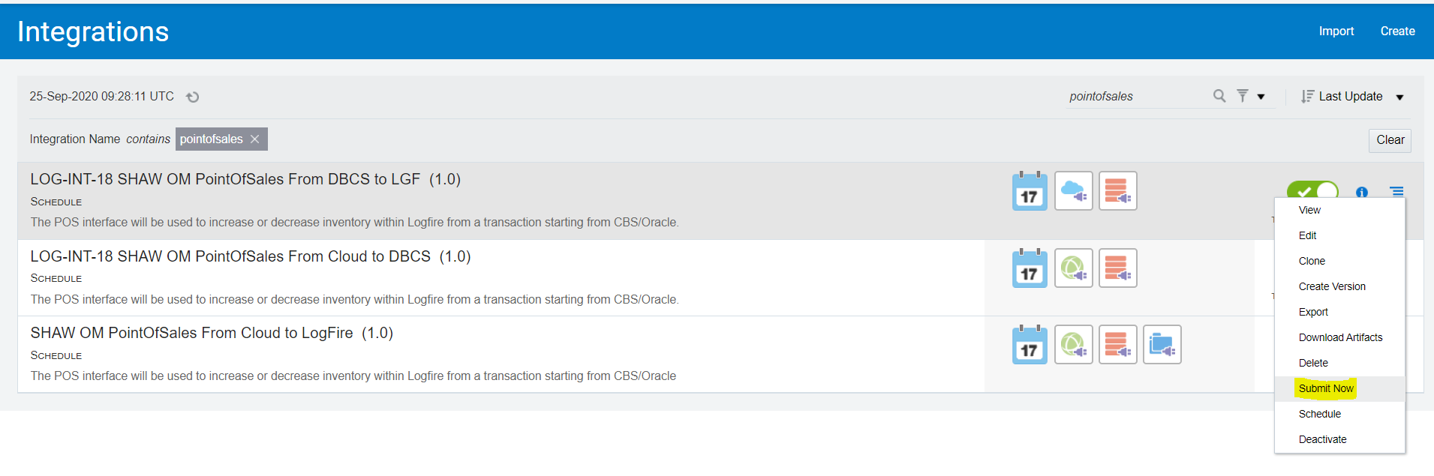



Check data of processed records for pos_status

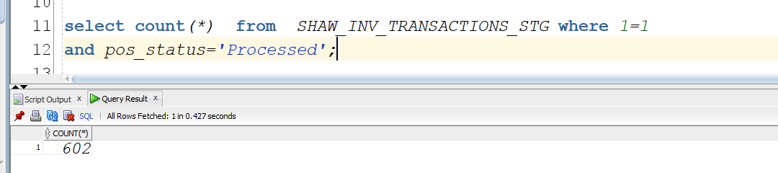

Data has been inserted in pos staging table

